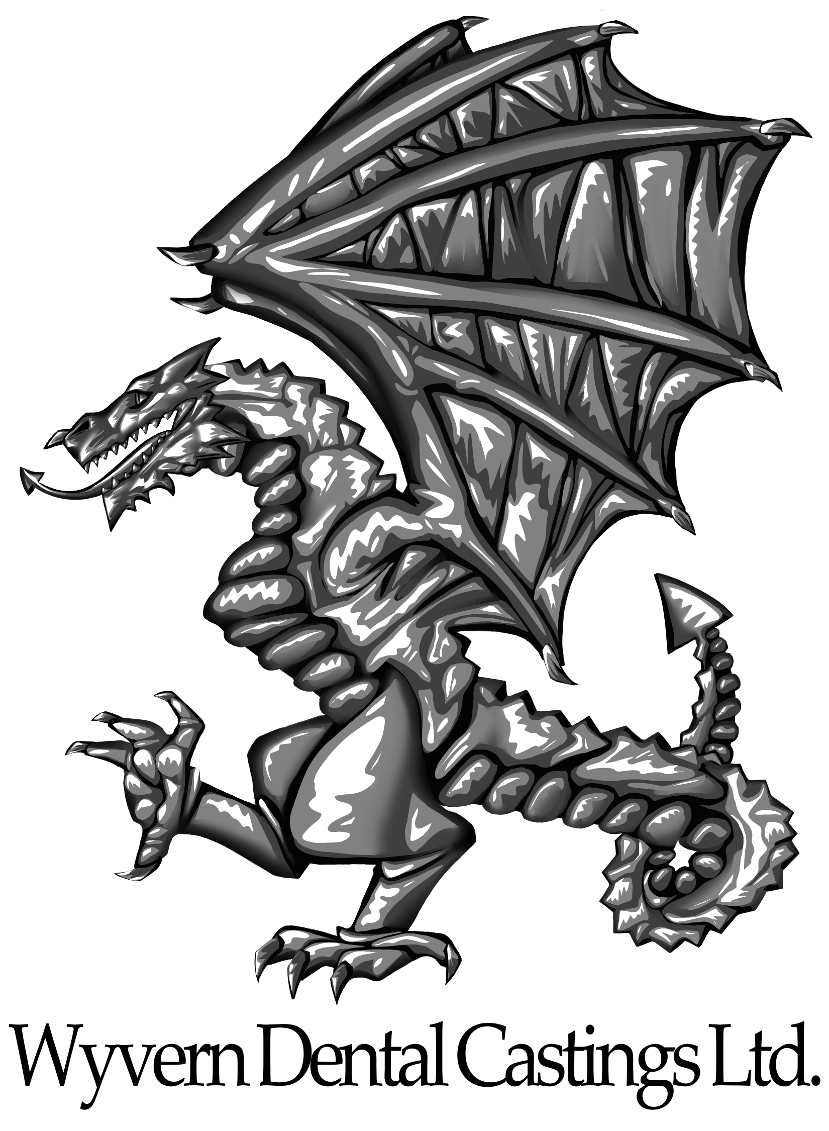
Wyvern Dental Laboratory Ltd.
Unit 1 Halthaies Workshops
Bradninch
Devon
EX5 4LG
01392 562710

Vitallium Framework Price List
(All prices are inclusive of clasps and rests, but are exclusive of model casting)

Full Upper £100
Full Lower £90
1-3 Tooth Plate £165
4-8 Tooth Plate £170
9-14 Tooth Plate £175
Single Bar £185
Multibar £190
Side Plate £120
Backing per tooth £20
Articulated Onlay £25
John Farrell Insert £70
Laser Welded Additions from £45
Model Casting £15

Lab to Lab prices upon request

